Sample JOIV Paper for A4 Page Size
Leave this box blank
Please submit online http://joiv.org/index.php/joiv/login in DOC file
Editor will not receive submission by email
Please be sure to check for spelling and grammar before submitting your paper.
First Author#, Second Author*, Third Author#
# Department, University, Address, City, ZIP Code, Country
E-mail: xxx@yyy.zzz
*Second Institution, Address, City, ZIP Code, Country
E-mail: xxx@yyy.zzz

Abstract— This document gives formatting instructions for authors preparing papers for publication in the International Journal on Advanced Science, Engineering and Information Technology. The authors must follow the instructions given in the document for the papers to be published. You can use this document as both an instruction set and as a template into which you can type your own text. PLEASE LEAVE THE SPACE ABOVE THE TITLE EMPTY. THE SPACE IS INTENTIONALLY SPARED FOR THE JOURNAL TITLE.

Keywords— Put your keywords here, keywords are separated by semi colon.

- Introduction
This document is a template. An electronic copy can be downloaded from the conference website. For questions on paper guidelines, please contact the conference publications committee as indicated on the conference website. Information about final paper submission is available from the conference website.
Authors are suggested to present their articles in the section structure: Introduction - The Material and Method/Algorithm - Results and Discussion – Conclusion. Please be sure that the manuscript is up to date. Reference minimal its 12 reference. It is expected that 30% of references are to recent papers. The minimum number of pages is as much as 6 pages, outside the references.

- Page Layout
An easy way to comply with the conference paper formatting requirements is to use this document as a template and simply type your text into it.
- Page Layout
Your paper must use a page size corresponding to A4 which is 210mm (8.27") wide and 297mm (11.69") long. The margins must be set as follows:
- Top = 19mm (0.75")
- Bottom = 28mm (1.1")
- Left = Right = 14.32mm (0.56")
Your paper must be in two column format with a space of 8.5mm (0.34") between columns.
- Page Style
All paragraphs must be indented. All paragraphs must be justified, i.e. both left-justified and right-justified.
- Text Font of Entire Document
The entire document should be in Times New Roman or Times font. Type 3 fonts must not be used. Other font types may be used if needed for special purposes. Recommended font sizes are shown in Table 1.
- Title and Author Details
Title must be in 18 pt Regular font. Author name must be in 11 pt Regular font. Author affiliation must be in 10 pt Italic. Email address must be in 9 pt Courier Regular font.
All title and author details must be in single-column format and must be centered.
Every word in a title must be capitalized except for short minor words such as “a”, “an”, “and”, “as”, “at”, “by”, “for”, “from”, “if”, “in”, “into”, “on”, “or”, “of”, “the”, “to”, “with”.
Author details must not show any professional title (e.g. Managing Director), any academic title (e.g. Dr.) or any membership of any professional organization.
To avoid confusion, the family name must be written as the last part of each author name (e.g. John A.K. Smith).
Each affiliation must include, at the very least, the name of the company and the name of the country where the author is based (e.g. Causal Productions Pty Ltd, Australia).
Email address is compulsory for all authors.
TABLE I
Font Sizes for Papers
Font Size | Appearance (in Time New Roman or Times)
Font Size | Regular | Bold | Italic
8 | table caption (in Small Caps),  figure caption,  reference item |  | reference item (partial)
9 | author email address (in Courier),  cell in a table | abstract body | abstract heading (also in Bold)
10 | level-1 heading (in Small Caps),  paragraph |  | level-2 heading,  level-3 heading,  author affiliation
11 | author name
24 | title

- Section Headings
No more than 3 levels of headings should be used. All headings must be in 10pt font. Every word in a heading must be capitalized except for short minor words as listed in Section III-B.
- Level-1 Heading: A level-1 heading must be in Small Caps, centered and numbered using uppercase Roman numerals. For example, see heading “III. Page Style” of this document. The two level-1 headings which must not be numbered are “Acknowledgment” and “References”.
- Level-2 Heading: A level-2 heading must be in Italic, left-justified and numbered using an uppercase alphabetic letter followed by a period. For example, see heading “C. Section Headings” above.
- Level-3 Heading: A level-3 heading must be indented, in Italic and numbered with an Arabic numeral followed by a right parenthesis. The level-3 heading must end with a colon. The body of the level-3 section immediately follows the level-3 heading in the same paragraph. For example, this paragraph begins with a level-3 heading.

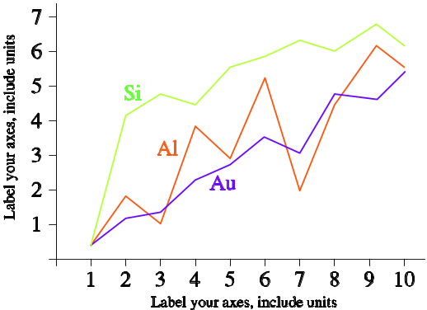
Fig. 1 A sample line graph using colors which contrast well both on screen and on a black-and-white hardcopy

- Figures and Tables
Figures and tables must be centered in the column. Large figures and tables may span across both columns. Any table or figure that takes up more than 1 column width must be positioned either at the top or at the bottom of the page.
Graphics may be full color. All colors will be retained on the CDROM. Graphics must not use stipple fill patterns because they may not be reproduced properly. Please use only SOLID FILL colors which contrast well both on screen and on a black-and-white hardcopy, as shown in Fig. 1.

Fig. 2 shows an example of a low-resolution image which would not be acceptable, whereas Fig. 3 shows an example of an image with adequate resolution. Check that the resolution is adequate to reveal the important detail in the figure.
Please check all figures in your paper both on screen and on a black-and-white hardcopy. When you check your paper on a black-and-white hardcopy, please ensure that:
- the colors used in each figure contrast well,
- the image used in each figure is clear,
- all text labels in each figure are legible.
- Figure Captions
Figures must be numbered using Arabic numerals. Figure captions must be in 8 pt Regular font. Captions of a single line (e.g. Fig. 2) must be centered whereas multi-line captions must be justified (e.g. Fig. 1). Captions with figure numbers must be placed after their associated figures, as shown in Fig. 1.


Fig. 2 Example of an unacceptable low-resolution image

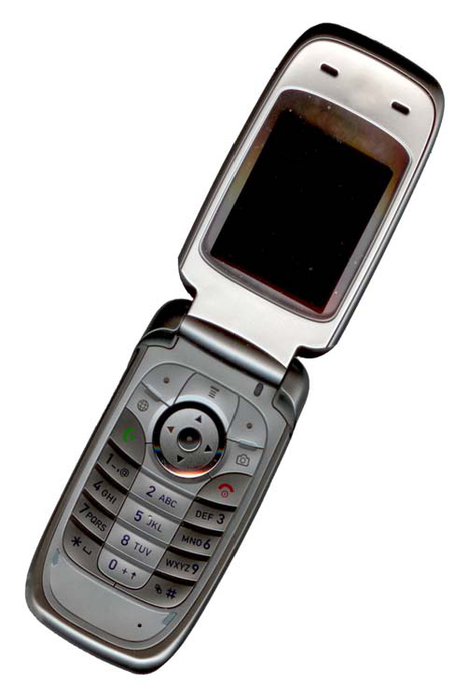
Fig. 3 Example of an image with acceptable resolution

- Table Captions
Tables must be numbered using uppercase Roman numerals. Table captions must be centred and in 8 pt Regular font with Small Caps. Every word in a table caption must be capitalized except for short minor words as listed in Section III-B. Captions with table numbers must be placed before their associated tables, as shown in Table 1.
- Page Numbers, Headers and Footers
Page numbers, headers and footers must not be used.
- Links and Bookmarks
All hypertext links and section bookmarks will be removed from papers during the processing of papers for publication. If you need to refer to an Internet email address or URL in your paper, you must type out the address or URL fully in Regular font.
- Equations
Equations should be placed flush-left with the text margin. Equations are centered and numbered consecutively starting from 1 as follows
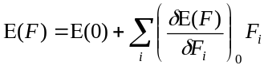 (1)
- References
The heading of the References section must not be numbered. All reference items must be in 8 pt font. Please use Regular and Italic styles to distinguish different fields as shown in the References section. Number the reference items consecutively in square brackets (e.g. [1]).
When referring to a reference item, please simply use the reference number, as in [2]. Do not use “Ref. [3]” or “Reference [3]” except at the beginning of a sentence, e.g. “Reference [3] shows …”. Multiple references are each numbered with separate brackets (e.g. [2], [3], [4]–[6]).
Examples of reference items of different categories shown in the References section include:
- example of a book in [1]
- example of a book in a series in [2]
- example of a journal article in [3]
- example of a conference paper in [4]
- example of a patent in [5]
- example of a website in [6]
- example of a web page in [7]
- example of a databook as a manual in [8]
- example of a datasheet in [9]
- example of a master’s thesis in [10]
- example of a technical report in [11]
- example of a standard in [12]

- Conclusions
The paper will not be reformatted, so please strictly keep the instructions given above, otherwise it will be returned for improvement. Please upload your paper in DOC file through the JOIV website (http://joiv.org) under Online Submissions menu. Papers sent by e-mail will not be processed.
Nomenclature
a specific surface area m²m⁻³
x length co-ordinate m

Greek letters
α heat transfer coefficient Wm⁻²K⁻¹
τ residence time s

Subscripts
i inlet
e equilibrium
Acknowledgment
We would like to thank Causal Productions for permits to use and revise the template provided by Causal Productions. Original version of this template was provided by courtesy of Causal Productions (www.causalproductions.com).
References
- S. M. Metev and V. P. Veiko, Laser Assisted Microtechnology, 2nd ed., R. M. Osgood, Jr., Ed. Berlin, Germany: Springer-Verlag, 1998.
- J. Breckling, Ed., The Analysis of Directional Time Series: Applications to Wind Speed and Direction, ser. Lecture Notes in Statistics. Berlin, Germany: Springer, 1989, vol. 61.
- S. Zhang, C. Zhu, J. K. O. Sin, and P. K. T. Mok, “A novel ultrathin elevated channel low-temperature poly-Si TFT,” IEEE Electron Device Lett., vol. 20, pp. 569–571, Nov. 1999.
- M. Wegmuller, J. P. von der Weid, P. Oberson, and N. Gisin, “High resolution fiber distributed measurements with coherent OFDR,” in Proc. ECOC’00, 2000, paper 11.3.4, p. 109.
- R. E. Sorace, V. S. Reinhardt, and S. A. Vaughn, “High-speed digital-to-RF converter,” U.S. Patent 5 668 842, Sept. 16, 1997.
- (2002) The IEEE website. [Online]. Available: http://www.ieee.org/
- M. Shell. (2002) IEEEtran homepage on CTAN. [Online]. Available: http://www.ctan.org/tex-archive/macros/latex/contrib/supported/IEEEtran/
- FLEXChip Signal Processor (MC68175/D), Motorola, 1996.
- “PDCA12-70 data sheet,” Opto Speed SA, Mezzovico, Switzerland.
- A. Karnik, “Performance of TCP congestion control with rate feedback: TCP/ABR and rate adaptive TCP/IP,” M. Eng. thesis, Indian Institute of Science, Bangalore, India, Jan. 1999.
- J. Padhye, V. Firoiu, and D. Towsley, “A stochastic model of TCP Reno congestion avoidance and control,” Univ. of Massachusetts, Amherst, MA, CMPSCI Tech. Rep. 99-02, 1999.
- Wireless LAN Medium Access Control (MAC) and Physical Layer (PHY) Specification, IEEE Std. 802.11, 1997.

Please be sure that the manuscript is up to date. Reference minimal its 12 reference. It is expected that 20 to 30% of references are to recent papers.

